8.81: a) Apply conservation of energy to the motion of the package from point 1 as it leaves the chute to point 2 just before it lands in the cart. Take y = 0 at point 2, so y₁ = 4.00 m. Only gravity does work, so

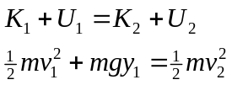
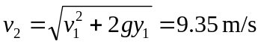

b) In the collision between the package and the cart momentum is conserved in the horizontal direction. (But not in the vertical direction, due to the vertical force the floor exerts on the cart.) Take +x to be to the right. Let A be the package and B be the cart.

P_{x} is constant gives
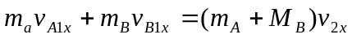
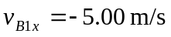
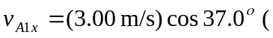The horizontal velocity of the package is constant during its free-fall.)
Solving for 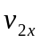 gives 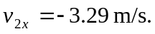The cart is moving to the left at 3.29 after the package lands in it.

